ASSIGNMENT 3

## NAME: ISHA PAWAR

## REG.NO.: 20BCE10297

EMAIL: [isha.pawar2020@vitbhopal.ac.in](mailto:isha.pawar2020@vitbhopal.ac.in)

Links to access:

Story: [https://public.tableau.com/shared/6YCY7B7WW?:display_count=n&:origin=viz_share_link](https://public.tableau.com/shared/6YCY7B7WW?%3Adisplay_count=n&%3Aorigin=viz_share_link)

Dashboard : [https://public.tableau.com/views/Assignment3_D1/Dashboard1?:language=en-US&publish=yes&:display_count=n&:origin=viz_share_link](https://public.tableau.com/views/Assignment3_D1/Dashboard1?%3Alanguage=en-US&publish=yes&%3Adisplay_count=n&%3Aorigin=viz_share_link)

Sales

Pie Chart

0

2,272,45

Region

Central East South West

Region (color) and sum of Sales (size).

Region. Color shows sum of Sales. Size shows sum of Proﬁt. The marks are labeled by Region.

|  |  |
| --- | --- |
| Tree Map | |
| West |  |
| South |
| East | Central |

Sales

388,984 713,471

# Heat Map

### 

Quantity

### 

Sales

|  |  |  |  |  |
| --- | --- | --- | --- | --- |
| Segment | Region | | | |
| Central | East | South | West |
| Consumer |  |  |  |  |
| Corporate |  |  |  |  |
| Home  Oﬃce |  |  |  |  |

997

2,000

3,000

4,000

5,000

6,264

73,931 357,819

Sum of Sales (color) and sum of Quantity (size) broken down by Region vs. Segment.

|  |  |  |  |  |  |  |  |  |  |  |  |  |  |  |  |  |  |  |  |  |  |  |  |  |  |  |  |  |  |  |  |
| --- | --- | --- | --- | --- | --- | --- | --- | --- | --- | --- | --- | --- | --- | --- | --- | --- | --- | --- | --- | --- | --- | --- | --- | --- | --- | --- | --- | --- | --- | --- | --- |
| Horizontal Barchart | | | | | | | | | | | | | | | | | | | | | | | | | | | | | | | |
| Region | Segment |  | | | | | | | | | | | | | | | | | | | | | | | | | | | | | |
| Central | Consumer |  | | | | | | | | | | | | | | | | | | | |  |  | |  | |  | |  | |  |
| Corporate |  | | | | | | | | | | | |  | |  | | |  | |  | |
| Home Oﬃce |  | | | | | |  | | |  | | |
| East | Consumer |  | | | | | | | | | | | | | | | | | | | | | | | |  |  | |  | |  |
| Corporate |  | | | | | | | | | | | | | | | |  |  | |  | |  | |  | |
| Home Oﬃce |  | | | | | | |  | |  | | |  | |  | | |
| South | Consumer |  | | | | | | | | | | | | | | |  | |  | |  | |  | |  | |  | |  | |  |
| Corporate |  | | | | | | | |  |  | | |  | |  | | |
| Home Oﬃce |  | | |  | |  | | | |
| West | Consumer |  | | | | | | | | | | | | | | | | | | | | | | | | | | | |  |  |
| Corporate |  | | | | | | | | | | | | | | | | |  | |  | |  | |  | |  | |  | |
| Home Oﬃce |  | | | | | | | | | |  | |  | |  | | |
|  | | 0 | 500 | 1000 | | 1500 | |  | 2000 | | | | 2500 | | 3000 | | 3500  Quantity | | | 4000 | | 4500 | | 5000 | | 5500 | | 6000 | | 6500 | |

Sum of Quantity for each Segment broken down by Region.

# Barchart

Category / Sub-Category

Furniture Oﬃce Supplies Technology

50K

40K

30K

20K

Proﬁt

10K

0K

-10K

-20K

Bookc.. Chairs Furnis.. Tables

Applia.. Art Binders Envelo.. Fasten.. Labels Paper Storage Suppli.. Access.. Copiers Machi.. Phones

Sum of Proﬁt for each Sub-Category broken down by Category.





Proﬁt

|  |  |  |  |  |  |  |  |  |  |  |  |  |  |  |  |  |  |  |  |  |  |  |  |  |  |  |  |  |  |  |  |  |  |  |  |  |  |  |  |  |  |  |  |  |
| --- | --- | --- | --- | --- | --- | --- | --- | --- | --- | --- | --- | --- | --- | --- | --- | --- | --- | --- | --- | --- | --- | --- | --- | --- | --- | --- | --- | --- | --- | --- | --- | --- | --- | --- | --- | --- | --- | --- | --- | --- | --- | --- | --- | --- |
| 25K |  | |  | |  | |  | |  | |  | |  | |  | |  | |  | |  | |  |  | |  | |  | |  | |  | |  | |  | |  | |  | |  | |  |
|  | |  | |  | |  | |  | |  | |  | |  | |  | |  | |  | |  |  | |  | |  | |  | |  | |  | |  | |  | |  | |  | |  |
| 20K |
|  | |  | |  | |  | |  | |  | |  | |  | |  | |  | |  | |  |  | |  | |  | |  | |  | |  | |  | |  | |  | |  | |  |
| 15K |
|  | |  | |  | |  | |  | |  | |  | |  | |  | |  | |  | |  |  | |  | |  | |  | |  | |  | |  | |  | |  | |  | |  |
| 10K |
|  | |  | |  | |  | |  | |  | |  | |  | |  | |  | |  | |  |  | |  | |  | |  | |  | |  | |  | |  | |  | |  | |  |
| 5K |
|  | |  | |  | |  | |  | |  | |  | |  | |  | |  | |  | |  |  | |  | |  | |  | |  | |  | |  | |  | |  | |  | |  |
| 0K |
|  | |  | |  | |  | |  | |  | |  | |  | |  | |  | |  | |  |  | |  | |  | |  | |  | |  | |  | |  | |  | |  | |  |
| -5K |
|  | |  | |  | |  | |  | |  | |  | |  | |  | |  | |  | |  |  | |  | |  | |  | |  | |  | |  | |  | |  | |  | |  |
| -10K |
|  | |  | |  | |  | |  | |  | |  | |  | |  | |  | |  | |  |  | |  | |  | |  | |  | |  | |  | |  | |  | |  | |  |
|  | 0 | 10 | | 20 | | 30 | | 40 | | 50 | | 60 | | 70 | | 80 | | 90 | | 100 | | 110 120  Quantity | | | 130 | | 140 | | 150 | | 160 | | 170 | | 180 | | 190 | | 200 | | 210 | | 220 | |

Sum of Quantity vs. sum of Proﬁt. Details are shown for Product Name.

Proﬁt

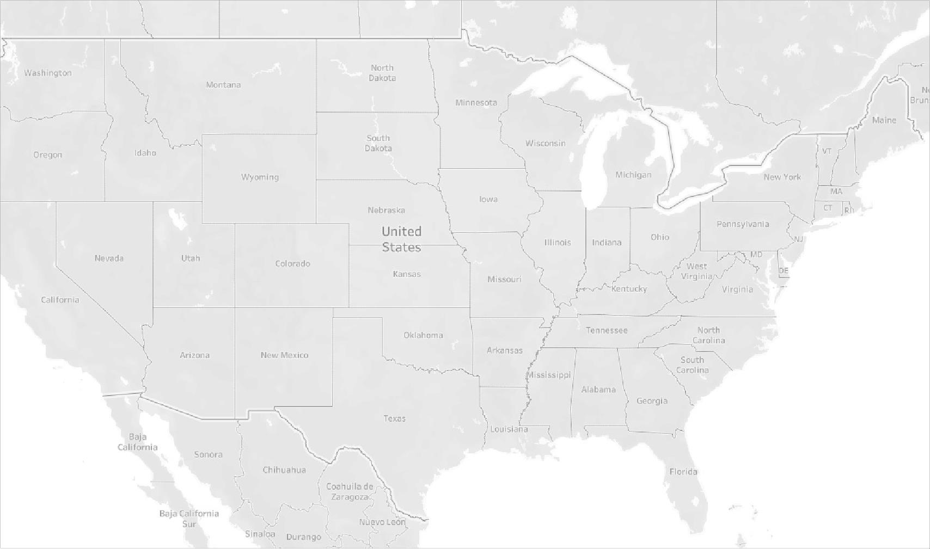

© 2023 Mapbox © OpenStreetMap

-25,535

0

20,000



40,000

60,000

74,669

Quantity

4 7,428



Map based on Longitude (generated) and Latitude (generated). Color shows sum of Quantity. Size shows sum of Proﬁt. Details are shown for Country and State.

Region

Central East South West

Sales

Pie Chart

## Heat Map

40K

20K

0K

-20K

Technology

Oﬃce Supplies

Furniture

Category / Sub-Category

Barchart

Proﬁt

Bookcases

Chairs

Furnishings

Tables

Appliances

Art

Binders

Envelopes

Fasteners

Labels

Paper

Storage

Supplies

Accessories

Copiers

Machines

Phones

Sales

Central

East

South

West

Tree Map

D2

|  |  |  |  |  |  |  |
| --- | --- | --- | --- | --- | --- | --- |
| Segment | Region | | | | | |
| Central | East | South | West | | |
| Consumer |  |  |  |  |  |  |
| Corporate |  |  |  |  | | |
| Home  Oﬃce |  |  |  |  | | |

73,931 357,819

Quantity

997

2,000

3,000

4,000

5,000

6,264

## Scatter Plot

Proﬁt

|  |  |  |  |  |  |  |  |  |  |  |  |  |  |  |  |  |  |  |  |
| --- | --- | --- | --- | --- | --- | --- | --- | --- | --- | --- | --- | --- | --- | --- | --- | --- | --- | --- | --- |
| Horizontal Barchart | | | | | | | | | | | | | | | | | | | |
| Region | Segment |  | | | | | | | | | | | | | | | | | |
| Central | Consumer |  | | | | | | | | | | | | |  |  | |  | |
| Corporate |  | | | | | |  |  | | | | |  | |
| Home Oﬃce |  | | |  | |  | |
| East | Consumer |  | | | | | | | | | | | | | | |  |  | |
| Corporate |  | | | | | | | | |  | | |  | |  | |
| Home Oﬃce |  | | | |  |  | |  | | | | |
| South | Consumer |  | | | | | | | |  | | | |  | |  | |  | |
| Corporate |  | | | | |  | |  | | | | |
| Home Oﬃce |  | |  | | |
| West | Consumer |  | | | | | | | | | | | | | | | | |  |
| Corporate |  | | | | | | | | | |  | |  | |  | |  | |
| Home Oﬃce |  | | | | |  | |  | | | | |
|  | | 0K | 1K | |  | 2K | | 3K  Quantity | | | | | 4K | | 5K | | 6K | |  |

|  |  |  |  |  |  |  |  |  |  |  |  |  |  |  |  |  |  |  |  |  |  |  |
| --- | --- | --- | --- | --- | --- | --- | --- | --- | --- | --- | --- | --- | --- | --- | --- | --- | --- | --- | --- | --- | --- | --- |
| 20K |  | |  | |  | |  | |  | |  |  | |  | |  | |  | |  | |  |
|  | |  | |  | |  | |  | |  |  | |  | |  | |  | |  | |  |
| 10K |
|  | |  | |  | |  | |  | |  |  | |  | |  | |  | |  | |  |
| 0K |
|  | |  | |  | |  | |  | |  |  | |  | |  | |  | |  | |  |
| -10K |
|  | 0 | 20 | | 40 | | 60 | | 80 | | 100 120  Quantity | | | 140 | | 160 | | 180 | | 200 | | 220 | |

Symbol Maps

Quantity

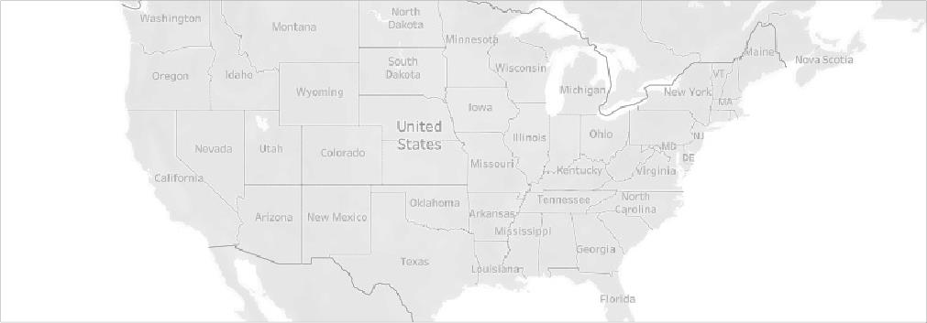

© 2023 Mapbox © OpenStreetMap

4 7,428

Proﬁt

-25,535

0



20,000

40,000

60,000

74,669

D1

Furniture

Category / Sub-Category

Oﬃce Supplies

Technology

50K

40K

30K

20K

10K

0K

-10K

-20K

Bookc.. Chairs Furnis.. Tables Applia.. Art Binders Envelo.. Fasten.. Labels Paper Storage Suppli.. Access.. Copiers Machi.. Phones

Proﬁt

|  |  |  |  |  |  |  |
| --- | --- | --- | --- | --- | --- | --- |
| A barchart demonstrating t.. | A Bar chart demonstrates th.. | A pie chart showng the regi.. | A Heat map based on Region wise s.. | Tree Map of region wise sales | Scatter plot consisting of pro.. | Map demonstrating t.. |

A barchart demonstrating t..

|  |  |  |  |  |  |
| --- | --- | --- | --- | --- | --- |
| A Bar chart demonstrates th.. | A pie chart showng the regi.. | A Heat map based on Region wise s.. | Tree Map of region wise sales | Scatter plot consisting of pro.. | Map demonstrating t.. |

Region Segment Central Consumer

Corporate Home Oﬃce

East Consumer Corporate Home Oﬃce

South Consumer Corporate Home Oﬃce

West Consumer Corporate Home Oﬃce

0

500

1000

1500

2000

2500

3000

3500

Quantity

4000

4500

5000

5500

6000

6500

|  |  |  |  |  |
| --- | --- | --- | --- | --- |
| A pie chart showng the regi.. | A Heat map based on Region wise s.. | Tree Map of region wise sales | Scatter plot consisting of pro.. | Map demonstrating t.. |

Region

A barchart A Bar chart demonstrating t.. demonstrates th..

Central East South West

Sales

2,272,450

|  |  |  |  |
| --- | --- | --- | --- |
| A Heat map based on Region wise s.. | Tree Map of region wise sales | Scatter plot consisting of pro.. | Map demonstrating t.. |

Quantity

A barchart A Bar chart A pie chart demonstrating t.. demonstrates th.. showng the regi..

|  |  |  |  |  |  |  |
| --- | --- | --- | --- | --- | --- | --- |
| Region | | | | | | |
| Segment | Central | East | South | West | | |
| Consumer |  |  |  |  |  |  |
| Corporate |  |  |  |  | | |
| Home  Oﬃce |  |  |  |  | | |

997

2,000

3,000

4,000

5,000

6,264

Sales

73,931 357,819

|  |  |  |
| --- | --- | --- |
| Tree Map of region wise sales | Scatter plot consisting of pro.. | Map demonstrating t.. |

Sales

A barchart A Bar chart A pie chart A Heat map based demonstrating t.. demonstrates th.. showng the regi.. on Region wise s..

|  |  |
| --- | --- |
| West | South |
| East | Central |

388,984 713,471



Proﬁt

A barchart A Bar chart A pie chart A Heat map based demonstrating t.. demonstrates th.. showng the regi.. on Region wise s..

Tree Map of region wise sales

Scatter plot

Map

consisting of pro.. demonstrating t..

|  |  |  |  |  |  |  |  |  |  |  |  |  |  |  |  |  |  |  |  |  |  |  |  |  |  |  |  |  |  |  |  |  |  |  |  |  |  |  |  |  |  |  |  |  |
| --- | --- | --- | --- | --- | --- | --- | --- | --- | --- | --- | --- | --- | --- | --- | --- | --- | --- | --- | --- | --- | --- | --- | --- | --- | --- | --- | --- | --- | --- | --- | --- | --- | --- | --- | --- | --- | --- | --- | --- | --- | --- | --- | --- | --- |
| 25K |  | |  | |  | |  | |  | |  | |  | |  | |  | |  | |  | |  |  | |  | |  | |  | |  | |  | |  | |  | |  | |  | |  |
|  | |  | |  | |  | |  | |  | |  | |  | |  | |  | |  | |  |  | |  | |  | |  | |  | |  | |  | |  | |  | |  | |  |
| 20K |
|  | |  | |  | |  | |  | |  | |  | |  | |  | |  | |  | |  |  | |  | |  | |  | |  | |  | |  | |  | |  | |  | |  |
| 15K |
|  | |  | |  | |  | |  | |  | |  | |  | |  | |  | |  | |  |  | |  | |  | |  | |  | |  | |  | |  | |  | |  | |  |
| 10K |
|  | |  | |  | |  | |  | |  | |  | |  | |  | |  | |  | |  |  | |  | |  | |  | |  | |  | |  | |  | |  | |  | |  |
| 5K |
|  | |  | |  | |  | |  | |  | |  | |  | |  | |  | |  | |  |  | |  | |  | |  | |  | |  | |  | |  | |  | |  | |  |
| 0K |
|  | |  | |  | |  | |  | |  | |  | |  | |  | |  | |  | |  |  | |  | |  | |  | |  | |  | |  | |  | |  | |  | |  |
| -5K |
|  | |  | |  | |  | |  | |  | |  | |  | |  | |  | |  | |  |  | |  | |  | |  | |  | |  | |  | |  | |  | |  | |  |
| -10K |
|  | |  | |  | |  | |  | |  | |  | |  | |  | |  | |  | |  |  | |  | |  | |  | |  | |  | |  | |  | |  | |  | |  |
|  | 0 | 10 | | 20 | | 30 | | 40 | | 50 | | 60 | | 70 | | 80 | | 90 | | 100 | | 110 120  Quantity | | | 130 | | 140 | | 150 | | 160 | | 170 | | 180 | | 190 | | 200 | | 210 | | 220 | |

A barchart A Bar chart A pie chart A Heat map based demonstrating t.. demonstrates th.. showng the regi.. on Region wise s..

Tree Map of region wise sales

Scatter plot

Map

consisting of pro.. demonstrating t..

7,428

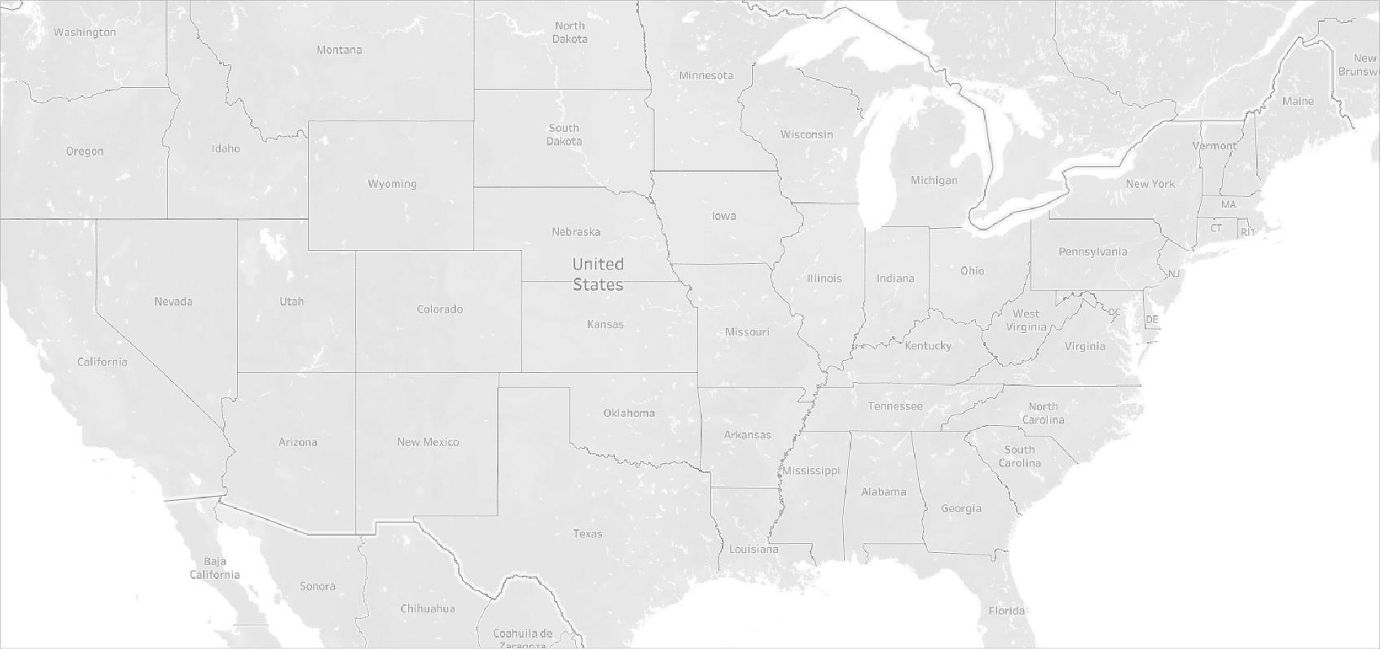

Quantity 4

Proﬁt

-25,535

0

20,000

40,000

60,000

74,669

© 2023 Mapbox © OpenStreetMap